Screenshot:

1 Show the link of Add employee and View Employee:

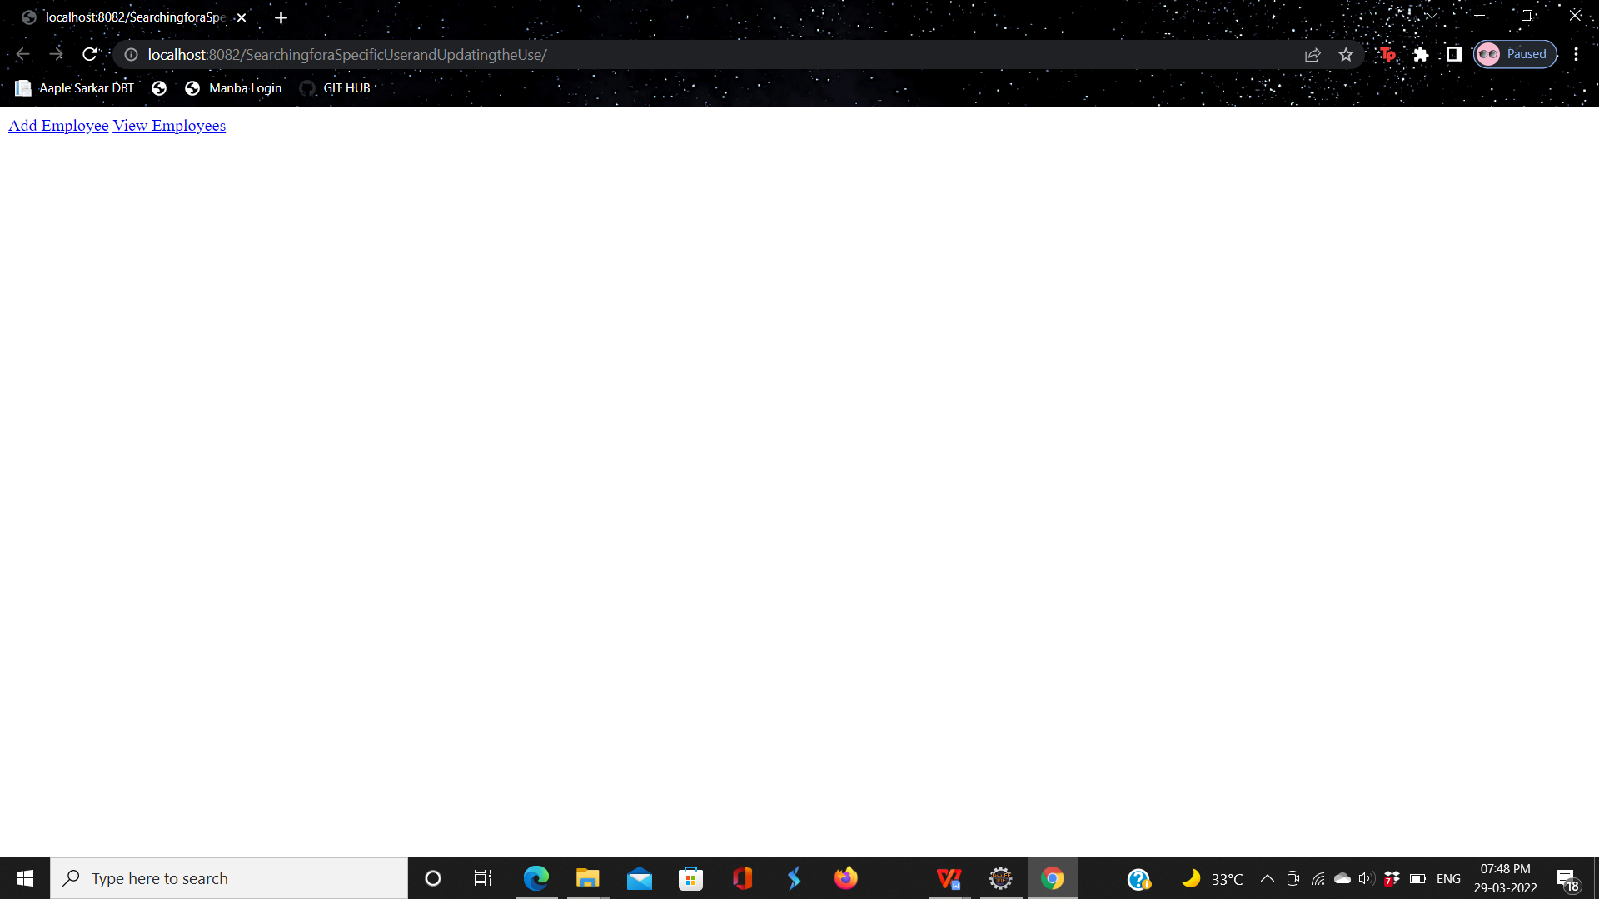

1. Click View Employee:

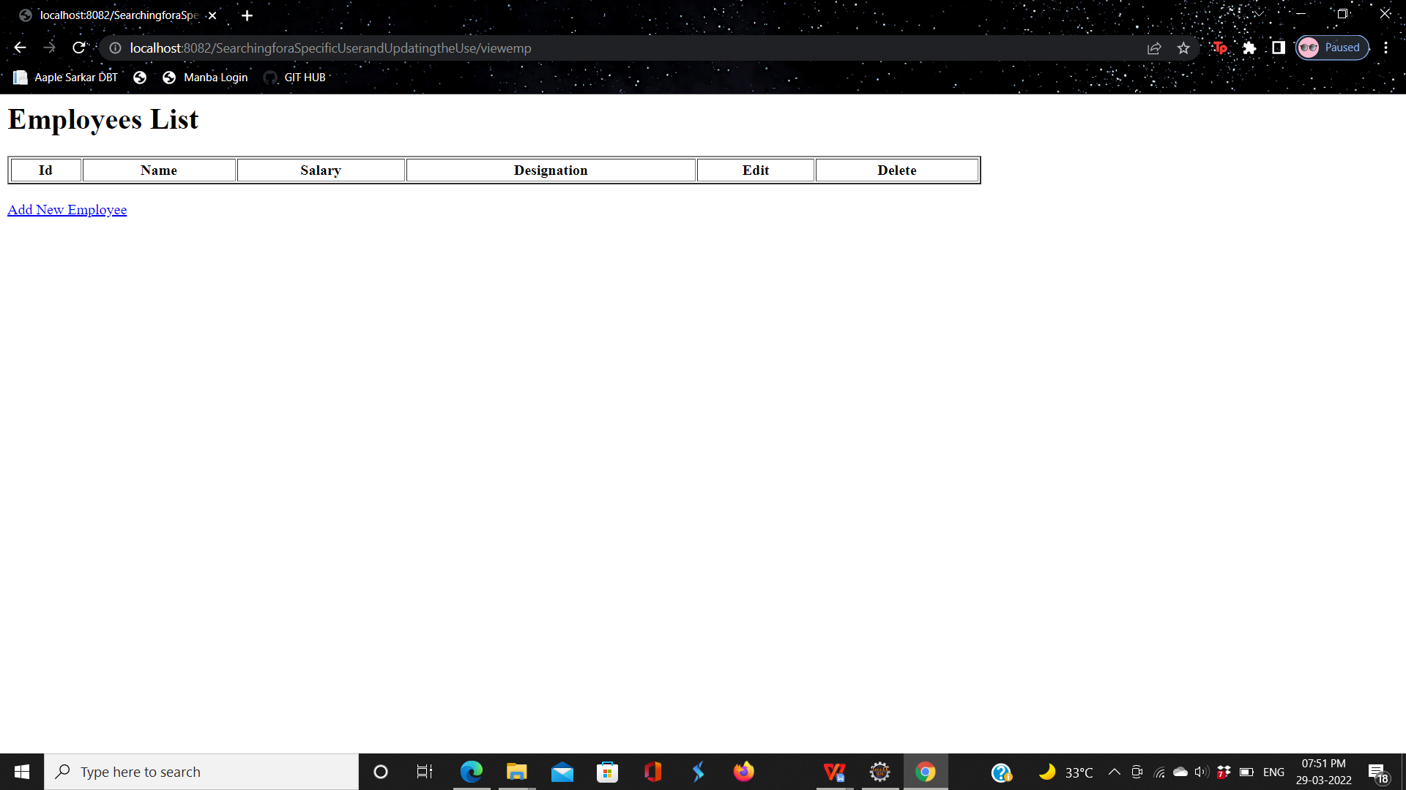

1. There is no Employee in Employee list click add new Employee and save:

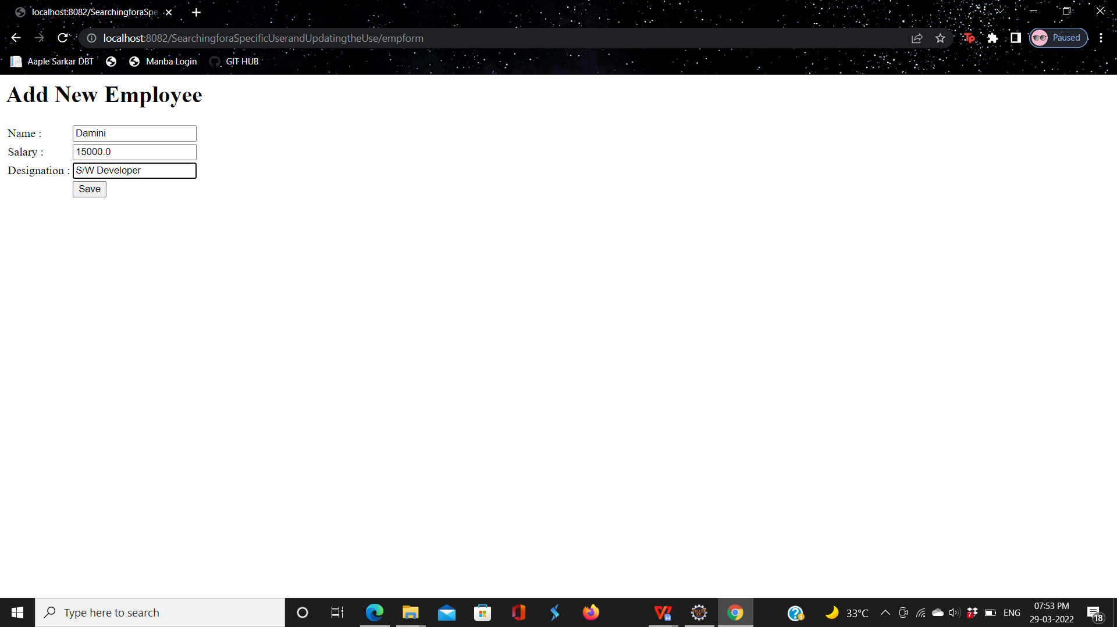

1. Add Employee Details in Employee list:

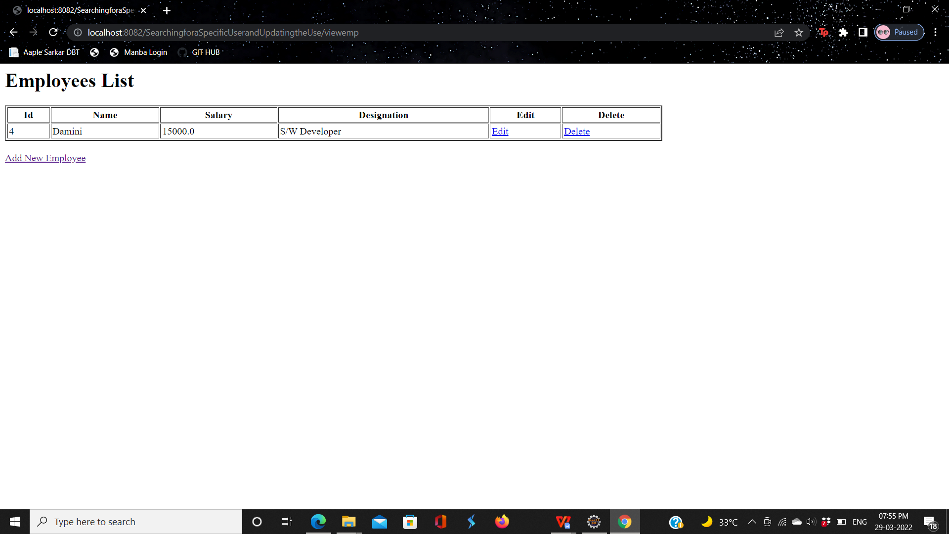

1. If you have changes in employee details click on edit option, eg I have change salary and click Editsave option:

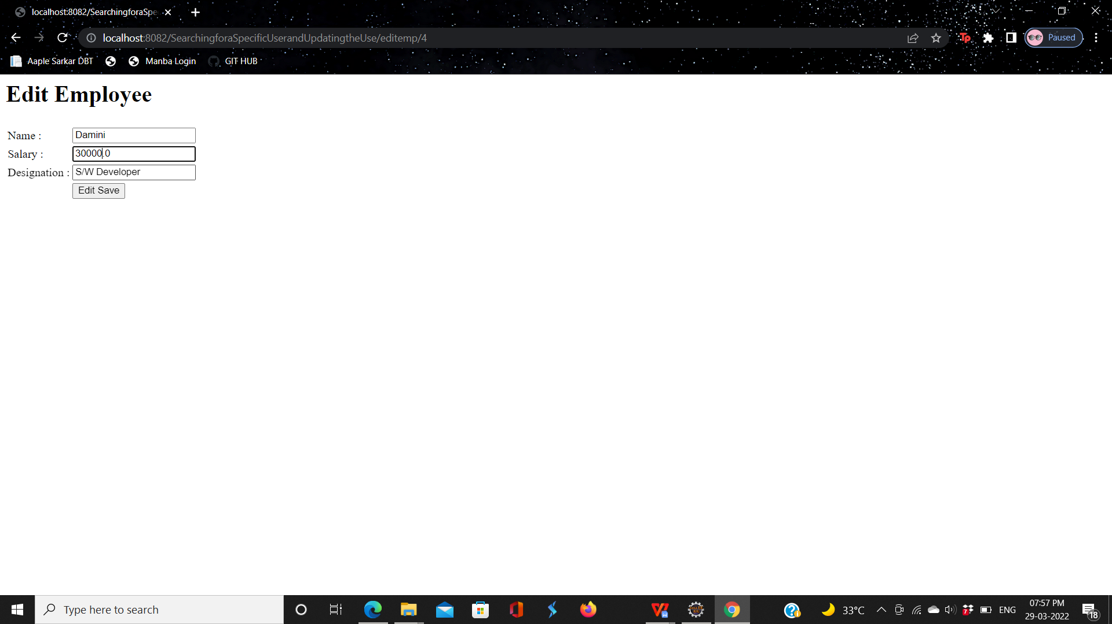

1. change salary of damini :

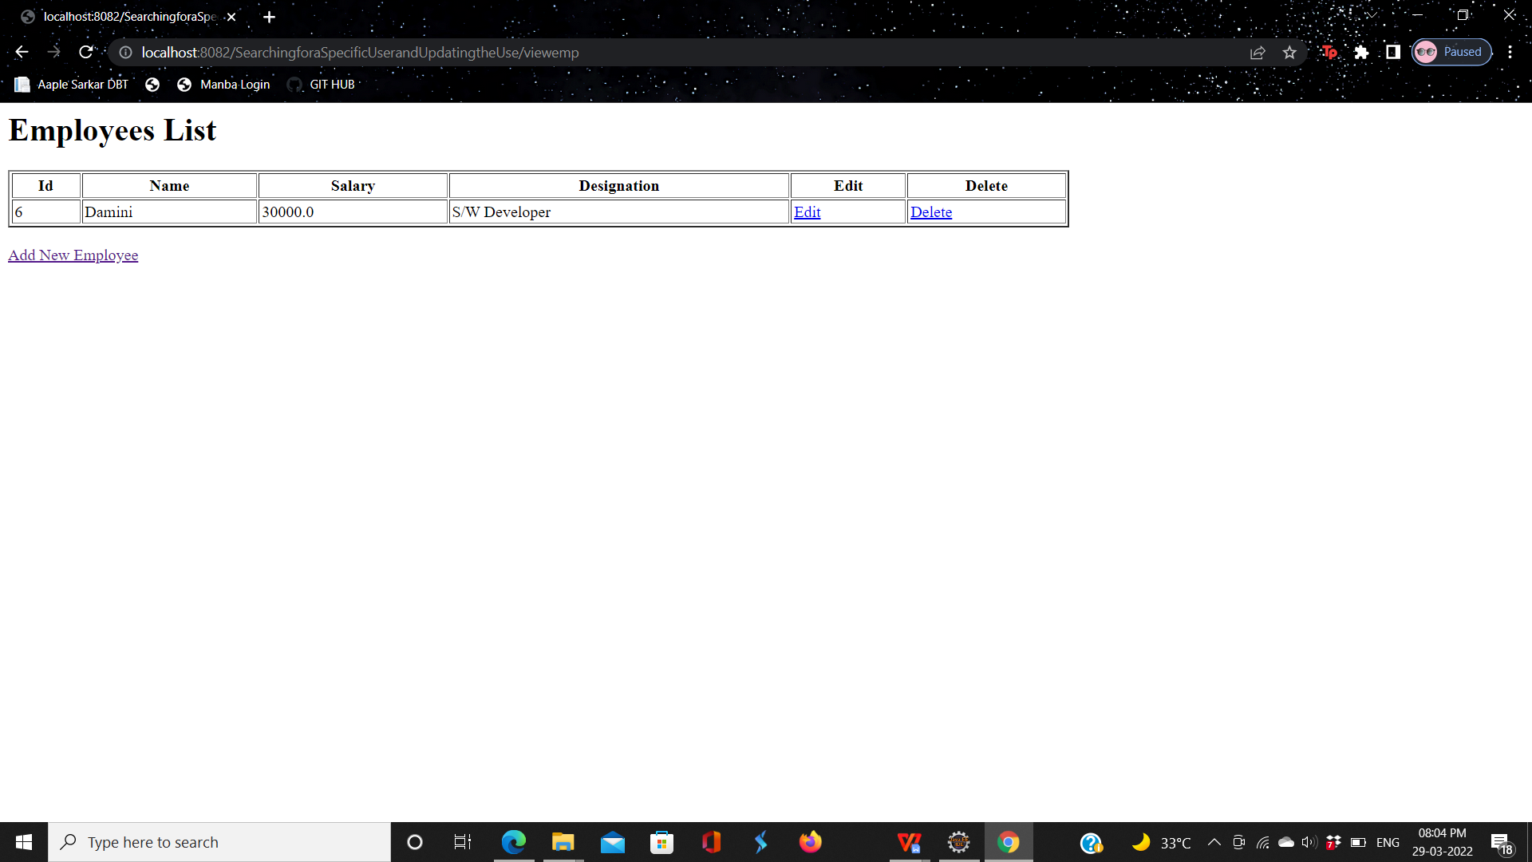

7. add Employee data in work bench :

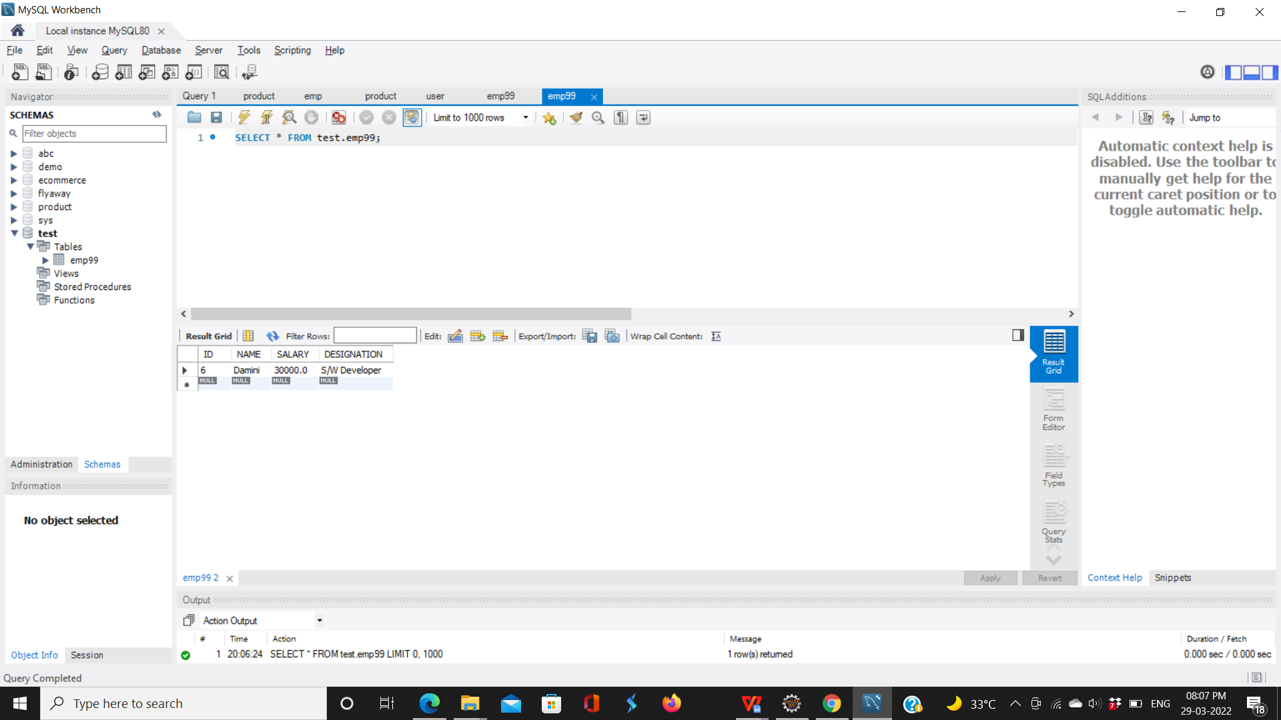

8. Delete Employee details in Employee List press delete option:

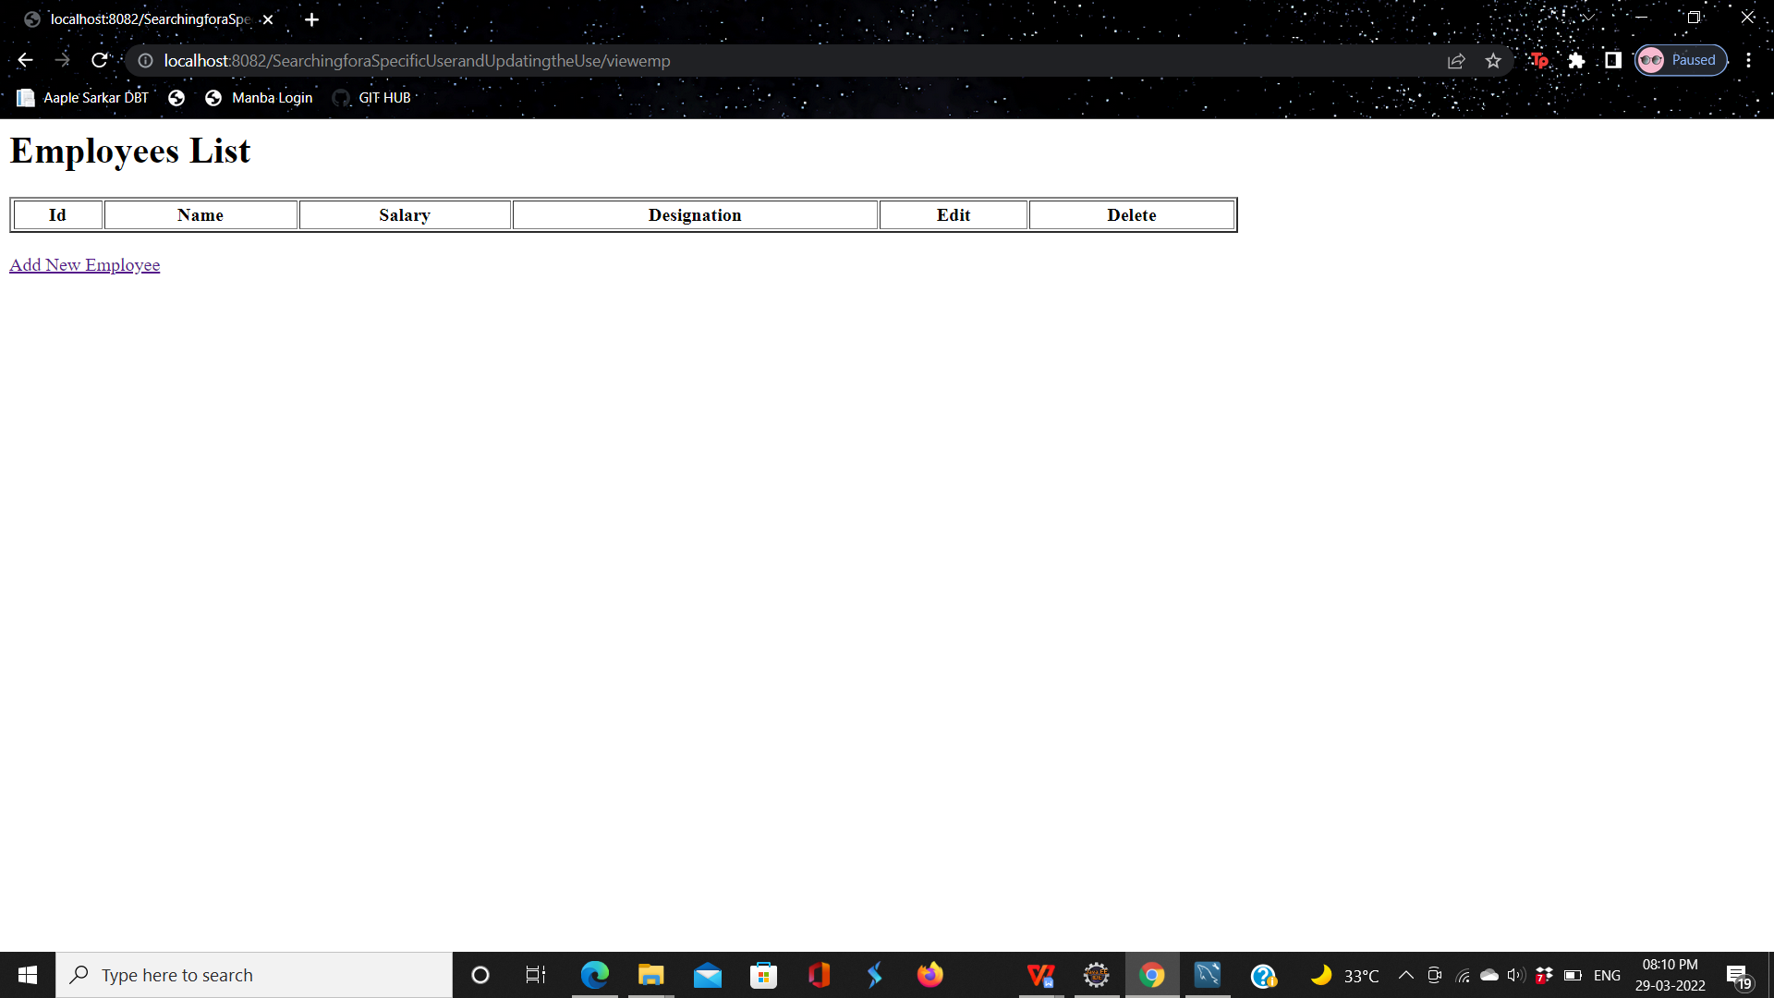

1. Also delete in database:

